Introduction
The Office of Academic Affairs (OAA) has spent this academic year developing a transparent and inclusive resource management process in collaboration with the University Council and Faculty Senate. Major units that are members of the OAA include all colleges, the research office, the graduate school, all vice provosts and their direct reports, enrollment management, the University libraries, the branch campuses and student affairs. The allocated budget to all units is approximately $150 million with nominally $50 million set aside for scholarships.
This document summarizes the extensive work of many groups with a goal of moving towards a shared budget and resource management approach. The primary shared governance body of the University is the University Council (UC), which has responsibility for strategic planning and resource management. The budget process is monitored by the UC’s Budget and Finance Committee (UCBF). Given that this effort is limited in scope to the OAA resource management and budget, the UCBF will be the primary recipient of the recommendations coming from this process annually. The Faculty Senate (FS) has enacted a committee to guide the process and get appropriate faculty participation and feedback. Faculty Senate has established the Academic Investment Committee (AIC) to work closely with the provost as part of the annual budget setting process and resource management. The AIC will provide periodic updates and reports to the FS going forward and will share its written updates and assessment with the UCBF.
The following sections touch on key topics that help explain what has occurred over this academic year to institutionalize a collaborative budget and resource management approach. The conceptual framework and timeline are first discussed for context. The AIC and the provost met frequently in the spring to move this concept into action, at least in a partial way. The narrative summarizes this year’s work but also points to things that we are already preparing to do in the next year. The appendix contains some details on the final funding recommendations based on the work of the OAA leadership, the AIC, the UCBF and the UA executive leadership.
Conceptual Framework
The old conceptual framework for resource management within OAA has been one of incremental and historic budget allocations. Typically, if there were increases or decreases in budgets across campus, most budgets would go up or down by the same percentage. Some units would occasionally convince leadership to invest in new ideas or initiatives, resulting in an episodic increase in that unit’s budget, which often would redefine a new, higher level of resources relative to other units (a bigger slice of the pie, so to speak). Likewise, there may have been directed reduction in the budget of a given unit. These episodic adjustments were well intentioned but not always understood by the larger University community since they seemed to occur through a process that was outside of the normal incremental budgeting process.
This new conceptual framework will use an annual process where all units on campus can make clear their priorities for new investment to their respective leadership. Thus, in the academic units, faculty would propose the department chair. The department chair would meet with the faculty and prioritize the ideas with the faculty’s input and provide those ideas to the dean. Likewise, an ongoing set of discussions would eventually bring priority requests to the provost from the many diverse groups within OAA. Utilizing a shared governance approach, the provost would then identify those priorities to fund and the sources of the needed funding. This work would be done in close collaboration with the AIC, the UC, the OAA leadership (deans, vice presidents, vice provosts etc.), and the University executive team.
The sources of funding for this process would include increases (or decreases) in budget allocation, earned revenue (e.g., fees or other alternative revenue streams) and reallocation of current resources. Budget allocation to the OAA areas is the purview of the president and the Board of Trustees. Any increase will be closely linked to increases in net tuition revenue. Although research activity does increase access to additional funding, that funding is restricted to activities related to the grant and is thus outside of this process. Only the Facilities and Administration (F&A) fees are flexible funds. To clarify, the F&A revenue is a minor contribution to the overall general fund budget. Undergraduate net tuition revenue accounts for most of our general fund, including the contribution from the State of Ohio as the State Share of Instruction (SSI). Thus, undergraduate instruction should be a significant factor in assessing productivity as well as new ideas for investment. Research and service are also vital to our mission at The University of Akron (UA) and will continue to deserve ongoing investment, especially as it impacts upon the undergraduate student experience at the UA.
In times of flat or declining revenue, this framework dictates that reallocation and earned revenue will be how resources will grow or shrink. Earned revenue is typically related to fees or specialized program delivery and the revenue earned is allocated to those units annually based on recent past performance. Such allocations would be independent of this larger process, although they will be shared transparently, as requested, and will guide decisions on the relative amount of ongoing general funds allocated to those units that have significant earned revenue. We rise together as a university community, so we must maximize the impact of the $150 million investment that students, parents, and the citizens of Ohio make in us each year. Reallocation will allow us to move funds to high priority initiatives over time. The normal process going forward will rely on the use of position vacancies to fund a reallocation pool, that will in turn be invested in our highest priorities as a university. To be clear, no current employment of an individual will be discontinued as part of this normal, ongoing reallocation process. Rather, we will rely on natural turnover in positions to scrutinize the highest and best use of those resources.
Timeline
The AIC was established at the beginning of this year and the development of this budget process was the first charge to this committee. It took the fall semester to appoint the committee and to start laying out the sequence of steps that OAA would need to orchestrate in order to fold into the budget planning process established by the chief financial officer (CFO) for the University. Key constituents that would need to remain aware and engaged in the process were identified and include the Faculty Senate, UC, the OAA leadership team (and thus the faculty through their deans), provost and the executive leadership. Thirteen guiding steps are outlined in the timeline grid below. This timeline is available on the UC website as well. These steps and the deadlines are guideposts and are not intended to be overly restrictive. Flexibility will be afforded with an eye towards meeting the cadence of the budgeting process but allowing time for transparent and meaningful engagement.
This timeline was agreed upon by all parties by January 2023. All parties agreed in advance that we would not be able to run the full process until the beginning of the 2023-24 academic year. Within that

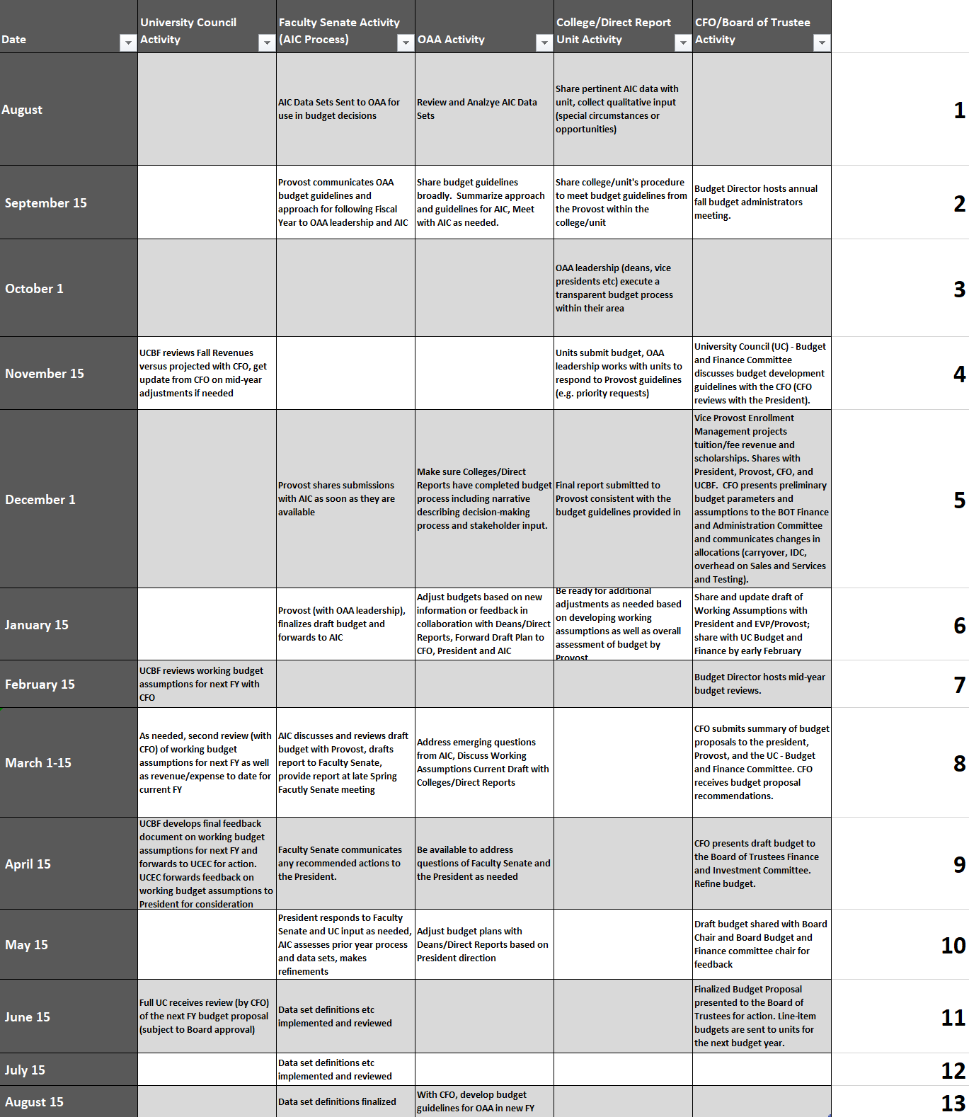

acknowledgment, we did agree to try to get the latter half of the process in motion this year, if possible. The remainder of this report details those efforts.
AIC Meetings and Deliberations
The AIC met frequently in the spring semester to discuss the investment process for the units within OAA. The guidance from the CFO and the budget office was that the OAA budget allocation would be flat. Thus, our primary means for investing in high priorities would come from new earned revenue sources or reallocation. The provost engaged with his leadership team and the AIC to conduct some “what if” scenarios and to home in on a budget that provides differential investments from current uncommitted resources. The provost organized this work as a two-step procedure. First, OAA leaders were asked to identify a few high priority requests that would be no more than a few percent increase in their budgets. That list has been compiled and shared. To meet those investment requests, the second step would require each area to contribute to a reallocation pool differentially. These shares would effectively be a budget cut but often offset by a budget increase related to the high priority request. The results of this two-step process can be seen in the appendix.
This approach of funding new investments by repurposing current resources has been occurring at all universities for many years, and it is not a new idea. Indeed, deans at the UA have been reallocating vacant positions on an ongoing basis in response to increasing/decreasing enrollment or service needs within their units. This current approach is different only in that it takes such a concept up to the OAA level. Such an approach is essential to appropriately fund growing and/or shrinking enrollments across the colleges or among other units.
The differential reallocation levels require a guiding measure that is rational and acceptable. The Faculty Senate took up this task and provided a list of quantitative measures that the AIC could suggest to the provost to utilize for the academic colleges. For the current year, the framework approved by the AIC relied primarily on the Delaware Cost Study to assess the relative budget provided to colleges to meet the instructional demands of the academic areas. Although not perfect, this data set is the best peer benchmark data available that can provide an objective estimate of the expenses required to deliver one student credit hour (SCH) in a given academic discipline. The expenditure per SCH reflects the differential salary levels of our faculty as well as the appropriate student-to-faculty ratio within a discipline. The range encompasses a sixfold difference in the cost to deliver an SCH. Some disciplines are more expensive than others, but often vital to our institutional mission. By coupling this benchmark with the actual SCH delivered by a department, we can arrive at an appropriate budget for that unit. Adding up all units within a college gives us a proxy for the college’s total budget. It was this college-level aggregation of benchmarked budget that was utilized to guide the differential allocation of the reallocation level. Budget reallocation levels included 0%, 0.5%, 0.75% or 1% of the base budget managed by that college or OAA unit. Some units were asked to reallocate much larger amounts and these actions are described below. Such benchmarks are not currently available for the non-academic units within OAA, but the AIC will be assessing possible ideas for the provost’s consideration in the next cycle.
The first “what if” iteration of this process made clear that we simply could not fund all the priorities that were requested. The AIC and the OAA leadership all recommended a much lighter touch be taken and that other opportunities for reallocation or new revenue be considered. Working with the CFO and the budget office, the provost identified an opportunity to more closely monitor our graduate remission pool to allow reallocation of the remission funding into operations. Both the AIC and the OAA leadership team have endorsed this approach. Although some believe the graduate remissions are not “real money,” this current plan appropriately recognizes that they are indeed completely equivalent to repurposing a vacant position on campus. In addition, the online fee was scheduled to be assessed this next academic year and the increased revenue can be directed to cover some general fund expenses in our office for distance learning. Those funds will also be directed to the reallocation pool.
By combining these additional sources, along with applying a modest budget reduction methodology, sufficient funds were identified to fund high priority projects in a manner that is not disruptive to the colleges and OAA units. Collegiate deans have made many commitments to fund new positions from ongoing positions vacancies and the plan allows them to continue to enact those plans. Any reallocation that is occurring in support of this budget plan is coming from position savings or vacancies within the units. Deans and OAA leadership will continue to have direct control over most of the funding and vacancies in their areas and current plans and localized processes should not be significantly disrupted.
Summary of Recommendations
The brief paragraphs in the appendix summarize the investments into each unit, along with the assigned reallocation amount. The overall approach will leave contingency funds for the next cycle each year given the necessity for such funds as the academic year unfolds. The initiatives proposed among the academic colleges had significant overlap in a few key areas that were identified for cooperative funding. In most cases, the funds were split for a given faculty position request among two colleges. One college is designated as the academic home for the faculty hire but only half of the needed funding is supplied to that one college. The partner college would have the other half of the funding which will assure an appropriate apportioning of the new faculty member’s productivity measure (SCH, research, service, etc.) to each of the cooperating colleges. The intent is to promote interdisciplinary and broader collegiate interactions. The cooperatives include one in nursing (CHHS and Wayne) and one in computing/data analytics (BCAS, CEPS, CoB). Other ideas proposed seem worthwhile, but funding was limited, and the next year could be spent firming up those interactions across campus. Other major investments were for enrollment management to provide a data analytics approach to maximizing our net tuition revenue through state-of-the-art optimization methods and to the Office of Research to address core support and compliance needs in support of our faculty researchers.
As part of the reallocation process, the management of what is currently called the graduate assistantship budget will be changed in a manner consistent with recommendations from the vice president of research, HR job descriptions, and discussion with the Graduate Council. Specifically, we will more clearly define roles and expectations of graduate students supported by the University’s general funds. Going forward, OAA will allocate teaching assistantships (TA) or research assistantships (RA). A TA or RA will continue to accrue a tuition remission from the remission budget as is current practice. Administrative graduate assistantships (AGA) can be offered by units throughout the University, but the AGA must be fully funded by the unit’s ongoing budget, including the tuition remission. The TA budget will be administered by the senior vice provost for academic and faculty affairs and the RA budget will be administered by the dean of the Graduate School. The current commitments to all graduate students, either currently enrolled or joining us in the fall, will be honored as we make this administrative transition. All appointments will continue to be administered through the Graduate School so the ongoing operations will not change.
Finally, the College of Engineering and Polymer Science (CEPS) had a professional fee that was “swapped out” for an equivalent amount of general funds in 2015. Although there was probably good reason to do this swap at the time, the college has requested to get that fee back so that it can accrue any increased revenue from enrollment increases or fee increases over time. Thus, there will be an even swap again to restore this fee directly back to CEPS. This change will treat CEPS in a comparable fashion to other colleges that have such a professional fee.
Anticipated Improvements Next Year
AIC suggests that there be more clarity about criteria that will be utilized in making decisions about allocation of resources into or out of the units. The criteria were informally communicated to the deans during this process, but it is appropriate to acknowledge that more clarity would be useful. Our discussions landed on some initial ideas that include the use of appropriate benchmarks of productivity (Delaware study, which includes both instructional benchmarks as well as research expenditure benchmarks), articulation of mission-critical needs vis a vis impact on institution (e.g., lack of teaching capacity preventing students from timely graduation), areas of national and international distinctiveness/excellence, and ongoing track record of successful return on investment. The AIC has recommended the continued use of the Delaware benchmarks. The AIC will need to provide its finalized guidance in the coming months so that the provost can include this information as part of the next budget cycle.
Regarding benchmarking, it would be appropriate to look at benchmarking availability for the non-academic areas. The University has recently investigated options such as Helios. The Performance, Strategy, and Insights (PSI) office will be consulted by the AIC to see if these other areas can also be benchmarked.
Finally, the new year will allow us to implement the process in its totality. The colleges and other OAA areas will be asked to push the process down to the frontline departments and units. The goal is to provide an inclusive process to surface the best ideas for investment. In parallel, the strategic planning work has resulted in five promise collectives which will also provide avenues for seed funding of ideas and are likely the best way to pilot an idea at small scale to strengthen a proposal for a recurring source of funds.

APPENDIX
Definitions of resource types:
Recurring resources are those funds that reside in the budget each year going forward and allow for hiring an employee for the long term or to meet an ongoing annual expense over an extended period of time.
One-time resources are a lump sum that is expended over a short period of time, typically within the same year that they are posted to a unit’s budget. Once spent, they are not automatically replenished each year.

Buchtel College of Arts and Sciences
Recurring: Two areas were ranked as the top priority in the college. Upon seeing all the other college proposals, the data analytics proposal seemed to be a better fit and more developed. One position (total salary and fringe of $110K) will be split with the College of Engineering and Polymer Science with the academic home being in Statistics.
The English Language Institute will be re-established given its importance to returning our international student body. The recurring budget totals $140K.
One faculty retention effort required a new NTT position which was partially funded from the strategic fund pool in OAA ($20K) earlier this year and is part of the new allocation to BCAS in the next fiscal year.
One time: Start-up funds for this faculty position ($60K)
Reallocation: 0.5% ($178,714)
College of Engineering and Polymer Science
Recurring: One top priority – School of Computing. I have asked Dean Menzemer to take the lead in this matter in a way that complements efforts in other partner colleges which currently includes the College of Engineering and Polymer Science (Computer Science, Cybersecurity, Computer Information Systems), the College of Health and Human Sciences (Digital Forensics), College of Business (Information Systems), and the Buchtel College of Arts and Sciences (Statistics/Data Analytics).
Requires 2 half positions ($110K for each position) to be leveraged with BCAS and COB and some operating funds ($20K). Additional position funding available in current collegiate plan (over $700K).
One time: Start-up funds for two computer science positions ($150K).
Reallocation: 1% ($267,844)

College of Health and Human Sciences
Recurring: Nursing NTT, Counseling TT, Coordinator for Associate of Arts in Nursing (split with Wayne) totaling $222,770
One time: $90,000 - vital discipline specific equipment provided as matching to be used with fundraising.
Reallocation: 0
College of Business
Recurring: Data analytics split with College of Engineering and Polymer Science (salary and fringe $110K or $55K per college)
One time: $100,000 – building updates, provided as matching to be used with fundraising.
Reallocation: 1% ($125,033)
School of Law
Recurring: Increasing scale of online Master’s in Law degree (staffing salary and fringe $90K)
One time: $60K - marketing and content development
Reallocation: 0.75% ($57,418)
Wayne and Branch Campuses
Recurring: $50K - Coordinator for Associate of Arts in Nursing (split with CHHS)
Reallocation: 0.75% ($34,979)
Student Affairs
Recurring: Student employment initiative ($55K) and Placement Testing Staff ($55K)
Reallocation: 0
Enrollment Management
Recurring: $1.525 million – modern data analytics implementation
Reallocation: 0
VP Research
Recurring: $297,415 - Addressing Workday software modification, compliance, and support staff
Reallocation: 0

Graduate School
Recurring: $6 million - Modified graduate remission budget; $250K – establish RA stipend budget
Reallocation: $12,560,745 (place whole GA stipends and remissions into reallocation pool but pull remissions, RA budget and TA budget back out explicitly)
University Libraries
Recurring: $79,740 (Salary and fringe) for staff to implement Open Scholarship Initiative as required by federal funding agencies
One time: $29,000 inflation on collections budget
Reallocation: 0
Senior Vice Provost for Academic and Faculty Affairs
Recurring: $4 million – TA stipend budget to be allocated to colleges based on transparent process linked to undergraduate teaching assistant needs in colleges
One time - $110K – Psychology Archives building envelope study, EXL fellow stipends, ITL summer support for faculty and ITL mini-grants
Reallocation: $433,567 – increased revenue from online fee reducing general fund needs
Vice Provost for Student Pathways
Recurring: $8,500 – expanded community outreach role for staff
One time - $230K - Choose Ohio First Summer Bridge program, First Year Experience pilot projects
Reallocation – 0.5% ($20,240)

